Warning
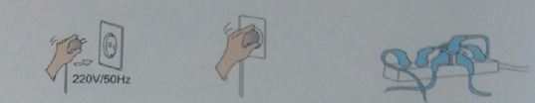

Make sure that the electric voltage and frequency is 220V/50Hz. Make sure plug is connected to socket properly.
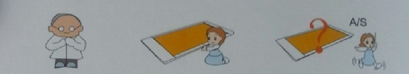
Do not plug into a power strip, it may be dangerous.

People with perception disabilities should be accompanied during use.

The healthy mattress is high temperature. Do not contact directly. Put a thin bed sheet or thin cloth on the healthy matt press before use

In case healthy the mattress is not in normal condition, stop using and contact us immediately.

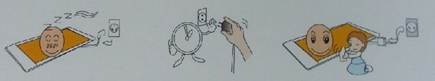
Unplug immediately after use to prevent circuit leakage and fire.

In the case of plugging in again please wait one minute if you have just used the mattress.

The user must remove the plug from the outlet any cleaning is going to be done to the mattress.

Important Instructive Information
∆ Please refrain from using any rugged or thick sheets on the bed because it can cause damage to the mattress.
∆ Do not use more than 12 hours a day and the wires must be grounded.
∆ Children and pregnant women should be supervised while using this mattress. Do not use with benign tumor patients.
∆ The life expectancy of the wires are approximately up to 5000 hours.

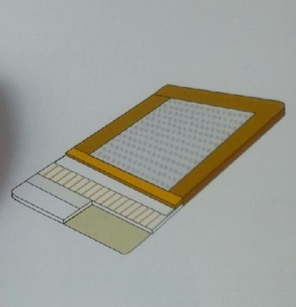

The benefits of the Jade mattress.
The benefits of the jade mattress.
1st layer: High quality leather.
2nd layer: Small complex hole-fiber and heat protection leather.
3rd layer: Jade Germanium Tourmaline Herbs
4th layer: Carbon-bamboo layer.
5th layer: Radiation protection.

6th layer: Silicon wires layer.
7th layer: Bio-Eco canvas.
8th layer: Heat reduction.
9th layer: The cotton incases the bio-eco layer.
10th layer: The high wavelength infrared radiation.
11th layer: The cotton incases the bio-eco.
12th layer: Heat protection.
13th layer: Moisture resistance.
1st layer:A good quality leather.
Beautifully designed, durable and easy to clean.
2nd layer: Small complex hole-fiber and heat protection leather
Use small complex hole-fiber and heat protection leather helps the mattress become more durable.
3rd layer: Jade germanium tourmaline herbs
4th layer: Carbon-bamboo layer
1. Absorbing layer: bamboo fiber absorbs 5 times better than others and it also absorbs dust, toxins and chemicals such as formaldehyde, benzene, toluene, ammonia and eliminates odors as well.
2. Release infrared and keep the heat: heats up faster than other materials.
3. Adjustable humidity : Adjustable humidity.
4. Release intensity minus atomic.
5. High in minerals.

The 5th layer: Radiation protection.
This layer has material that protects you from magnet wave and toxic radiation.
The 6th layer: Silicon wire.
This layer has material which is able to heat up faster, become more durable, efficienct and tough on pulling and folding. It also absorbs the engergy from body to produce heat reaction to help the other layers heat up quickly this will help enlarge all the veins and pores for better circulation.
The 7th layer: Bio-canvas
Help increase the heat.
The 8th Heat reduction.
Helps to keep and reduce the heat from Infrared radiation in order to spread the heat constantly to all over mattress.
The 9th layer: The cotton incases the bio-eco layer.
To position the high wavelength.
The 10th layer: The high wavelength Infrared radiation
The natural materials commonly trades the electrons, the magnetfield which is built by this called “Earth Magnetic Radiation” has the wavelength of 4-14 microns those numbers are equal to the sun. It is built by the change of the wind at 60 rounds by both North and South in 1 second. This Earth’s Magnetic Field is related to all of materials such as mirror, rubber and rocks.

The 11th layer: The cotton incases the bio-eco layer.
To position the high wavelength.
the 12th layer: Heat protection.
To protect the mattress from the heat.
The 13th layer: Moisture resistance.
This layer is made of cow tendon and makes mattress durable, tough on rubbing against each side.

Note: This mattress is not a long wavelength.The 10th layer is to install the electrical device.
(Internet info)

The benefits of the healthy mattress.
- Warm just like the heat mattress ( Ancient Chinese used in the old days) adjustable by seasons, warm in winter or cold in summer.
- Cures the cause of cold feet symptom and the weak knees.
- Skin improvement; smoother and more flexible.
- Make you calm, good for the veins circulation and the organs.
- Helps reduce the pains of headache, stomachache and help with the nervous system.
- Release the positive infrared to your body to help the cells increase more new cells to maintain good health.

(Internet info)

What kind of person needs the healthy mattress
1. The ones who don’t have enough time to rest, fatigue from long working hours, lack of exercising, and drink or smoke too much. The jade mattress can help these people to reduce their fatigue including enhance their power’s life.
2. For the ones who suffer from general illnesses, the jade mattress will release infrared to stimulate cell building and blood circulation. Electrons will be used to recover their health and protect them from any illness.
3. For the ones who would like to take care of their beauties. Infrared from the jade mattress will permeate into the pores and stimulate the skin to sweat. From these reasons, their skin will look more radiant.
4. For the students who are preparing to enter universities. Using the jade mattress will help to expand blood vessels and pores for better blood flow to the brain including reduce the fatigue and improve sleeping efficiency.
Does electromagnetic waves have a negative effect on human body?
- Has a negative effect on brain
- Has a negative effect on the immune system
- Has an effect on blood vessels
- Has an effect on blood system
- Has an effect on reproductive system and heredity
- Has an effect on eye sight
- Can develop cancers
(Internet info)

Tips
∆ anion (negatively-charged electricity): We feel cool fresh air when we are in the forest, waterfall or hot spring, because there is much anion in the air around there/ much anion exists. Atom emitted electron turns to be cation, on the other hand atom received electron is called anion. When the body gets anion, the body regenerate new cells more rapidly- making the body feel fresh, increasing the blood volume, calm the brain and increases appetite. So anion is considered as “Vitamin from air”

- To purify blood
Anion purifies blood by increasing blood calcium, sodium and potassium ,resulting in more alkalinity in blood.
- To increase metabolism
Increasing of anion in cell stimulates substance exchange at cell membrane, cytogenesis and excretion, resulting in rapid excretion of wasted substance out of body.
- To increase immunization
Anion increases immunoglobulin and immunization against contagious diseases. To use anion as complimentary treatment will shorten the time for noticeable effective treatment.
- To balance autonomic nervous system
Anion regulates autonomic nervous system which controls thought, sensation including blood vessels and internal organs, resulting in good effects for human body .Therefore, anion can stimulate organs, nervous system, blood circulation and lymph node active and bring life back to weak organs again.

∆ anion(negatively-charged static electricity): Anion Therapy is one of the electrostatics therapy by inducing electromagnetic field and
places the patient exposure to anion in electromagnetic field. Anion will stimulate human metabolism.
- To purify blood
Anion increases concentration of blood calcium ion and blood sodium ion, resulting in weak alkalinity in blood and eradicate substance such as cholesterol which is accumulated in blood vessels. Prevent arteriosclerosis and acute paralysis including other diseases related to blood circulation system.
- To stimulate gastric and intestinal chemical digestion
Anion is not only a stimulate gastric and intestinal chemical digestion,but also prevents bacterial overgrowth. Enhances gastric and intestine to work properly, resulting in good excretory system and reduces symptoms occur from digestive system.
- To enhance health during sleep
Using anion while sleeping does not keep you awake, on the contrary relieves your body and makes your bedtime fulfilled with happiness and comfort until dawn, resulting in being healthy surprisingly.

∆ High wavelength magnetic wave: There is electrons transfered in natural material. Magnetic fields induced by electrons transfer is called natural magnetic field. Its wavelength is about 5-6 million meters, equal to wavelength of the sunwave which is orginated from the alternation of wind between north pole and sourth pole 60 round per minute. This magnetic field is related to every material such as mirror, rubber or stone. If you are exposed to such magnetic field, your blood circulation improves, muscle relaxes and even delays pain.High wavelength magnetic field line originated from continuous alternation of magnetic field as cycle till it becomes magnetic wave. High wavelength magnetic wave is potentially effective to nervous system including to vertebral column, reduces cumulative fatigue, increase magnetism in body structure such as carbon, oxygen, nitrogen, manganese, magnesium and iron, including the increased rate of cell regenerate.

∆ Infrared : Sun radiation in everyday life for example x-ray, UV is electromagnetic wave. Infrared can be divided into three categories according to variation of wavelength: low wavelength infrared, medium wavelength infrared and high wavelength infrared. High wavelength infrared is beneficial for the human body. When high wavelength infrared go through any layer of material in which atomic vibration frequency is close to or similar to wavelength of infrared, atomic vibration resonance will occur and become heat.

∆ Silicon thermo-coil Material quality of thermo-coil meets the standard. Speed warming, endurance to high temperature, effective, endurance to stretch and bend. Silicon thermo-coil can bring body energy to form heat reaction and encourage increasing temperatures quickly. Blood vessels and pore will dilate and help blood circulation to improve. Eliminate substance which interferes new cell regeneration.

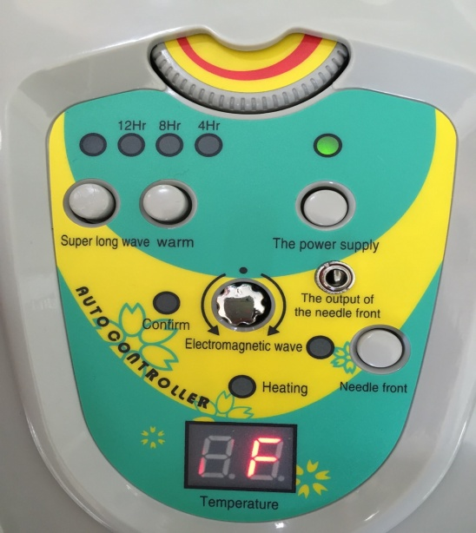
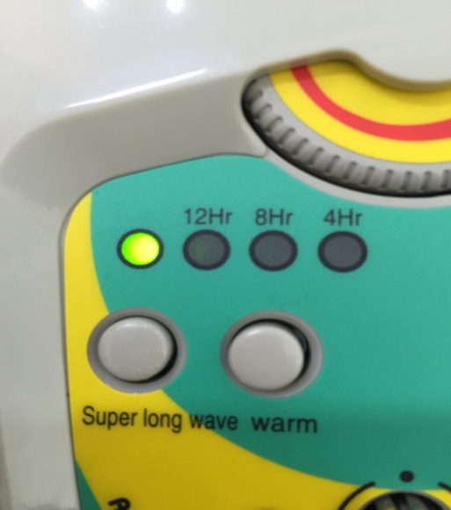
- Power on-off button

Push 1 time to start the wave which will shut down within 30 minutes.

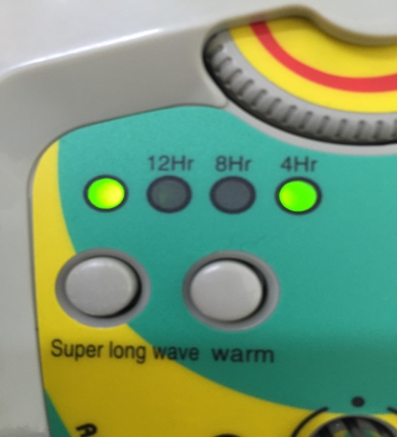
Push the Timer button 4,8,12 Hours
Spinner to adjust Temperature
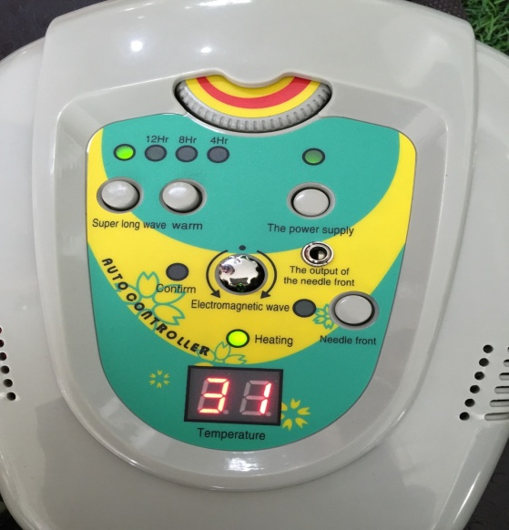

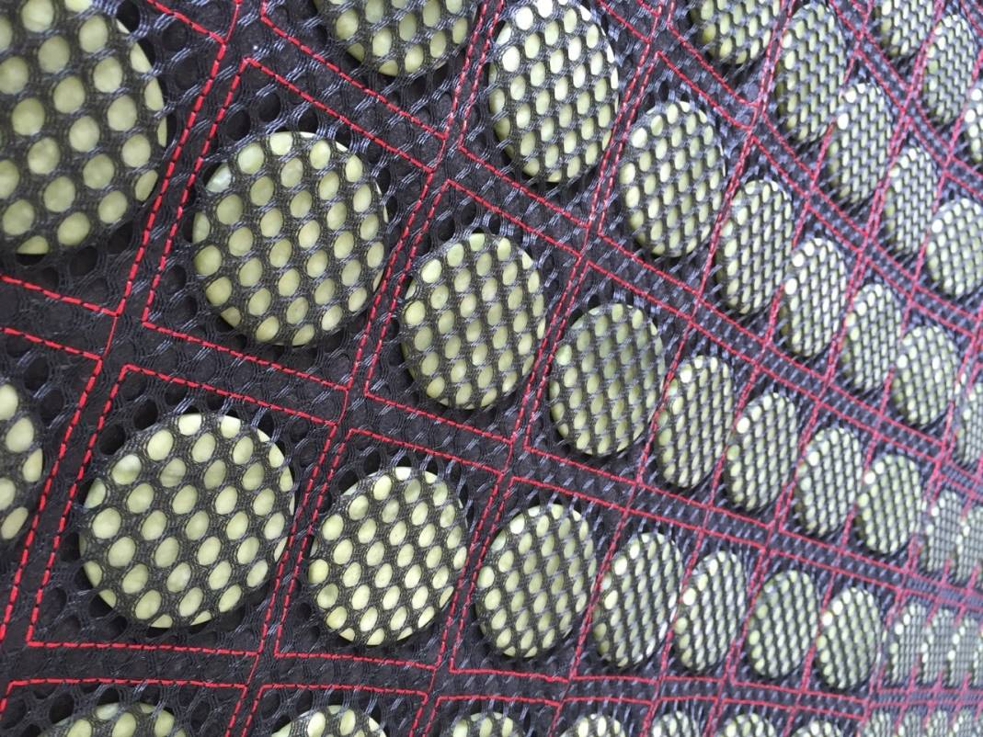

The heat will gradually increase to the jade until it reaches the adjusted temperature.

Functions on the remote control
- On/ off switch. Button to turn the mattress on/ off
- Power indicator. When indicator lights up, you can adjust to the desired temperature.
- Timer switch to set temperature time
- Temperature controller
- Temperature indicator
- Wave amplitude button
- Electromagnetic wave controller
- Electromagnetic wave indicator
- Heat Indicator
- Control needle button
- Indicator lights up when control needle is put in

Comparison of product model specifications

Mattress Type | One-way thermal adjusted  healthy mattress | One-way thermal adjusted  healthy mattress | One-way thermal adjusted  healthy mattress | One-way thermal adjusted  healthy mattress
Mattress model | RK-100*190-8x | RK-120*190-7x | RK-150*190-6x | RK-180*200-3x
Remote control model | MAO-09sD220V~50Hz | MAO-09sD220V~50Hz | MAO-09sD220V~50Hz | MAO-09sD220V~50Hz
Voltage/ Frequency | 220V/50Hz | 220V/50Hz | 220V/50Hz | 220V/50Hz
Power | 218W | 315W | 405W | 525W
Size and Weight | 100x190m×12 (cm/kg) | 120x190m×12 (cm/kg) | 150x190m×12 (cm/kg) | 180x190m×12 (cm/kg)
Temperature Capacity | 25°C-75°C | 25°C-75°C | 25°C-75°C | 25°C-75°C

Prescriptions
- Read the handbook thoroughly.
- Place the mattress horizontally.
- Check the electrical potential/voltage (220V/50Hz.)
- Plug in the mattress in a plug socket.
  - The rate of voltage must be verified.
  - The receptacle (socket) must be rechecked.
Instructions and directions
- Plug in the remote control device with the healthy mattress. Make sure they are fastened as shown in the picture.
- Switch on the remote control device (the switch button glows). The double-line signal appears on the numerical scale.
- Press the button ‘Warm’ to set the time (the green light on ‘Heating’ glows) to 12 hours or reset to 8 hours/ 4 hours/ or switch off. While using the mode ‘Warm’, temperature can be adjusted by using the tuning button. The scale will show the figures (10 to 70 Celsius) until the mattress gets warmed up gradually as the temperature is set. The ‘Warm’ mode stops functioning when the green light on ‘Heating’ is out. The mattress keeps the set temperature. The scale shows vertical double lines. The device will turn off automatically as the time is set.
- Tune up the button ‘Electromagnetic Wave’ clockwise or counter-clockwise. Prevent a danger of electromagnetic wave by ensuring that the green light above the button is out.
- Press the button ‘Super Long Wave’. The device functions for 30 minutes until it automatically turns off.
- Press the button ‘Needle Front’. Insert the needle into the needle cavity ‘The Output of the Needle Front’. The needle is then available.
- While using the healthy mattress, do not place the remote control device on the mattress.
- Do not remove or replace the remote control device while attached to the mattress.
- Switch off and plug off after using the mattress.

Precautions for the Healthy Mattress’s User
- Read the handbook thoroughly before using.
- The proper rate of electrical potential (voltage) is at 220V/50Hz only.
- Disabled, adolescents and those who are insensible to heating are not permitted to use the mattress alone.
- The mattress cannot be used when soaked/wet.
- Do not adjust or fix the remote control device as individually favored.
- When the light goes out, switch it off and adjust the temperature to its minimum rate by using the remote control device.
- Check the mattress and the remote control device regularly to avoid any of irregularities. In case of that or misusage, please contact the sales department or inform us to send the product back.
- While using, do not place the healthy mattress on any other soft mattress. In case this item is violated, a leading cable which controls temperature can get torn. Do not place the healthy mattress on any other adjustable mattress, unless the leading cable gets torn and/or stuck.
- In case the cable or remote control device gets damaged, please send it to the maintenance shop immediately.
10. Please use the remote control device that given with it at first hand.
11. Not allowed to take off any part of the product.
12. Do not use or insert any sharp material (needle) into ‘The Output of the Needle Front’.
13. In case the circuit breaker gets broken, please send back to the company and have it repaired. Do not fix it yourself.
14. When using the warm mattress all night, the time of heating should be further set to 6 hours, not to 12 hours.

Caution after use the healthy mattress
- Clean the health mattress before storage.
- Warm the healthy mattress for a short time to reduce accumulation humidity.
- Keep the healthy mattress in anti-dust bag.
- Storage place should not be high humidity no good ventilation.
- Always check up and expose to sunlight after storage.
- Do not put heavy things on the healthy mattress during storage.

How to clean healthy mattress
- Always turn off the switch during cleaning the healthy mattress.
- Use a dry cloth to clean the healthy mattress.
- Use a vacuum to pull dust around small space between jade stone. Always keep the healthy mattress dry and prevent from any liquid and water.
- Should dry the healthy mattress after cleaning.
- Use a dry towel to clean remote temperature control.
Always keep the healthy mattress clean to maintain product quality.
After-sales service
- Warranty period
- Warranty period for repairing after checkup shall cover a period of 2 years

- If any following defect arises within warranty period, your product will be repaired at no charge.
- Failure or defect occurs from product quality
- Failure or defect occurs when end user follows the user guide strictly.
- The warranty does not apply to any:
- Defect not originated from product quality for example damage caused by improper use, or defect caused by

natural disasters. Repair service fee will be charged from user.
- Defect occurs when product is not in use.
- If the product has been opened and/or no sticker showing manufacturing date and ISO logo.
- If dirty water or drinks is found within the product.
- Damage caused by plugging into other improper devices.
- Damage caused by negligent of user.
- If the product has been previously repaired by unauthorized person.
- Damage due to use contrary terms and conditions stated in the user guide.
∆ Read and follow instructions and cautions stated in the user guide strictly for longer use.
∆ Must have sticker showing manufacturing date and ISO logo behind remote temperature control and the healthy mattress.

Genuine Product must have 3 signs!
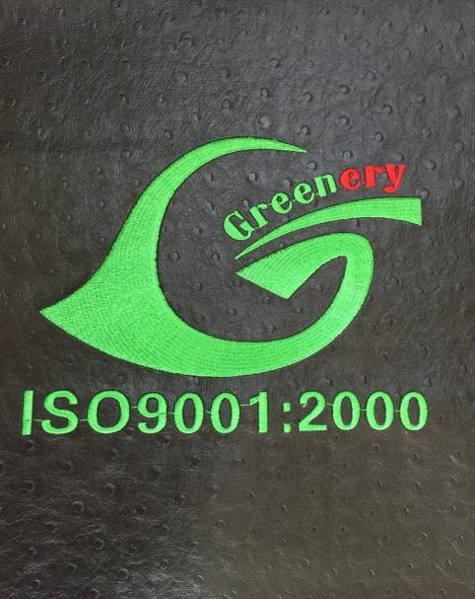
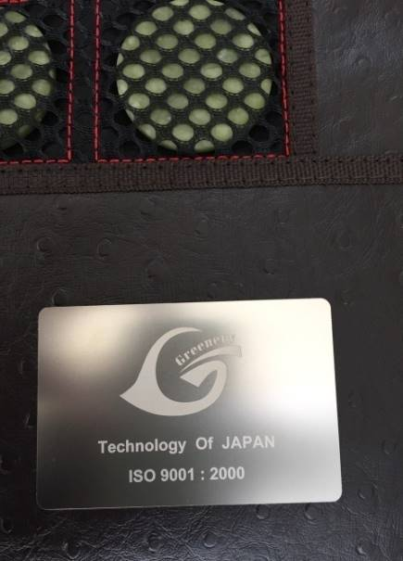
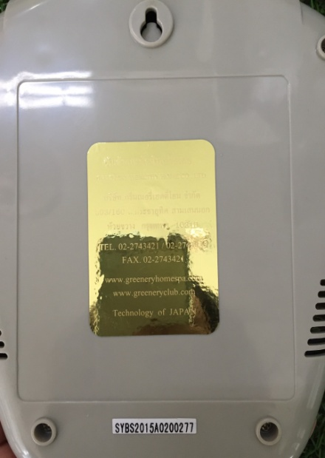

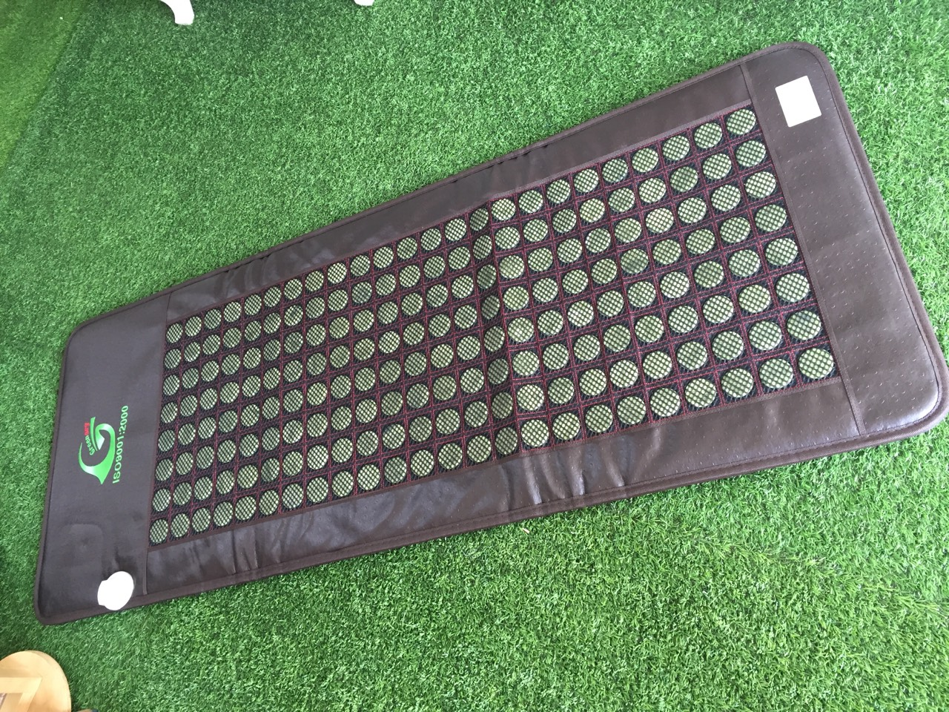

Note: It is recommended that users should take the mattress for checking and maintenance at the Service Center every two years in order to maintain the lifetime of the mattress and to avoid electromagnetic waves. If you have any questions with respect to checking and maintenance periods, please do not hesitate to contact our customer services at the dealer.

Product Name ___________________
Series ___________________
Date ______ / ______ / __________
Dealer____________________________________
Customer Name ______________ Telephone:_______________

Dealer Name_______________________________
Customer Name___________________________
Telephone_______________________________
Dealer Stamp_____________________________
Product Name ___________________
Series ___________________
Date ______ / ______ / __________
Dealer____________________________________
Customer Name ______________ Telephone:_______________

___________________
ตราประทับ (สำหรับร้าน) _________________________________________

Product Name ___________________
Series ___________________
Date ______ / ______ / __________
Dealer____________________________________
Customer Name ______________ Telephone:_______________

___________________
ตราประทับ (สำหรับร้าน) _________________________________________

Product Name ___________________
Series ___________________
Date ______ / ______ / __________
Dealer____________________________________
Customer Name ______________ Telephone:_______________

___________________
ตราประทับ (สำหรับร้าน) _________________________________________

